**Documentation of Version Control system**

**TechTrio-Freelance Agency**

|  |  |
| --- | --- |
| Group member name | Roll number |
| Amama Jawaid | 21sw029 |
| Rida Shah | 21sw059 |
| Kashish Kumari | 21sw074 |
|  |  |

**Overview**

We've carefully outlined the steps taken to integrate a version control system into our website development workflow. This documentation offers a systematic guide, ensuring clarity and precision in the implementation of version control. Concurrently, a separate Word file contains a comprehensive record of our website, serving as a dedicated reference point for its functionality, structure, and features.

This dedicated document streamlines collaboration and enhances transparency in our version control processes, providing a thorough resource for all stakeholders involved in the development and maintenance of our website.

STEP 1

Committing landing page code to central repository.

21sw029 worked on the landing page (index.html) to give an initial base to the website on her local machine then pushed the changes to the central repository on github.

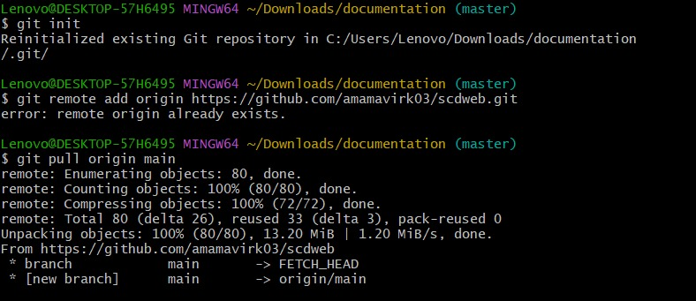

STEP 2

Making branches for each page of the website

We've structured our task delegation by assigning specific pages on the website to individual team members, each granted access to their distinct branches for development. Following completion, the designated member merges their respective page changes into the main branch. The breakdown is as follows:

- 21sw029: Assigned to the Landing Page with a focus on the "index.html" file.

- 21sw059: Responsible for the Services and Contact Us pages.

- 21sw074: Tasked with the development of the Meet Our Team and About Us pages.

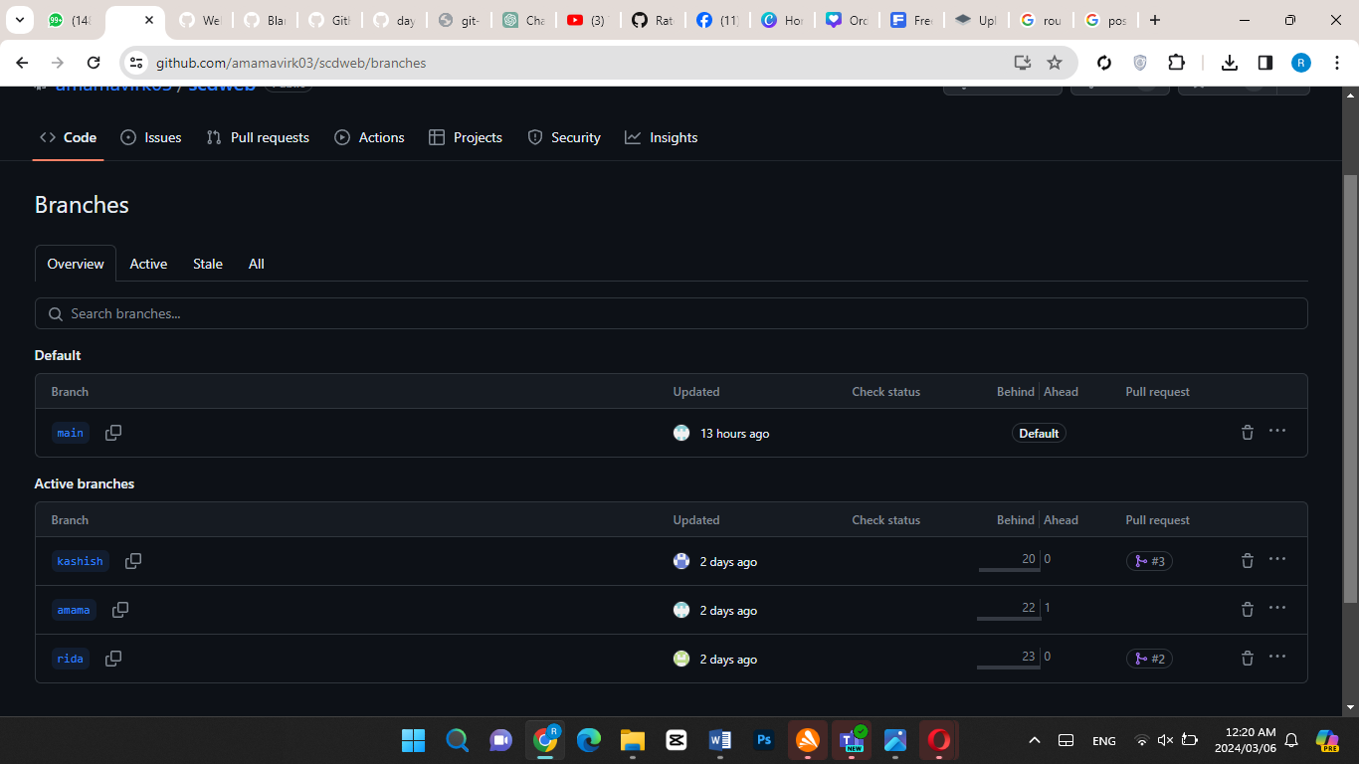

STEP3: Merging to the main branch

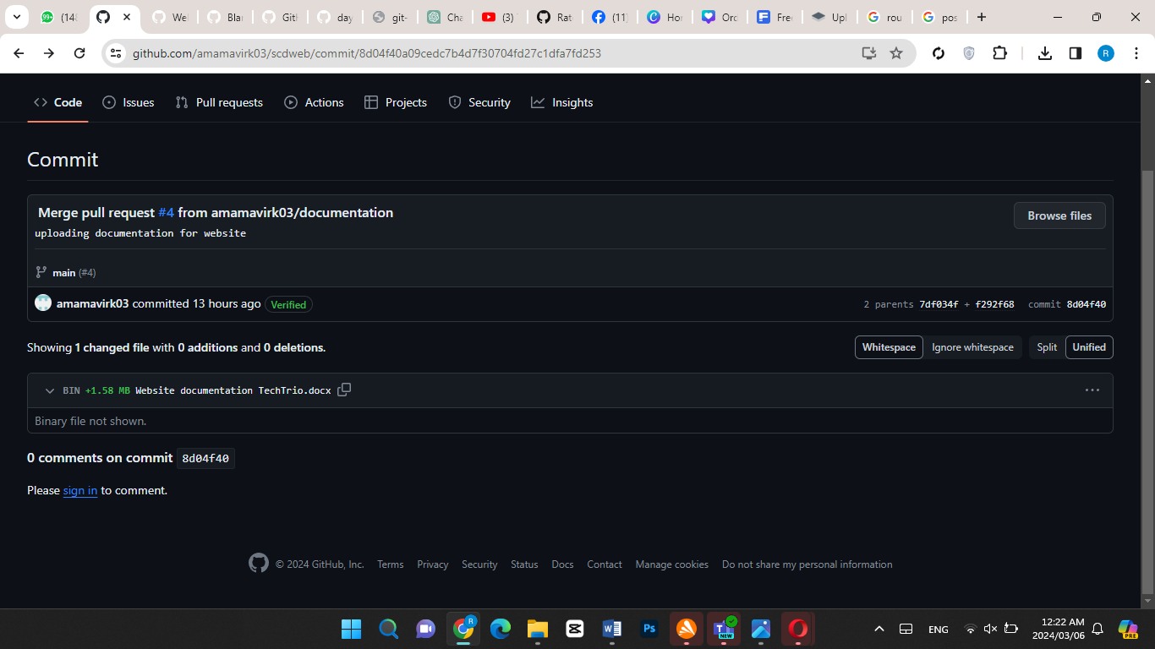

STEP 4: Changes made to conflict.txt file

We recorded conflicts in a "conflict.txt" file as part of our commitment strategy. However, when team members made separate changes to the same file, conflicts arose. This highlighted the need for effective communication to prevent such issues in collaborative development.

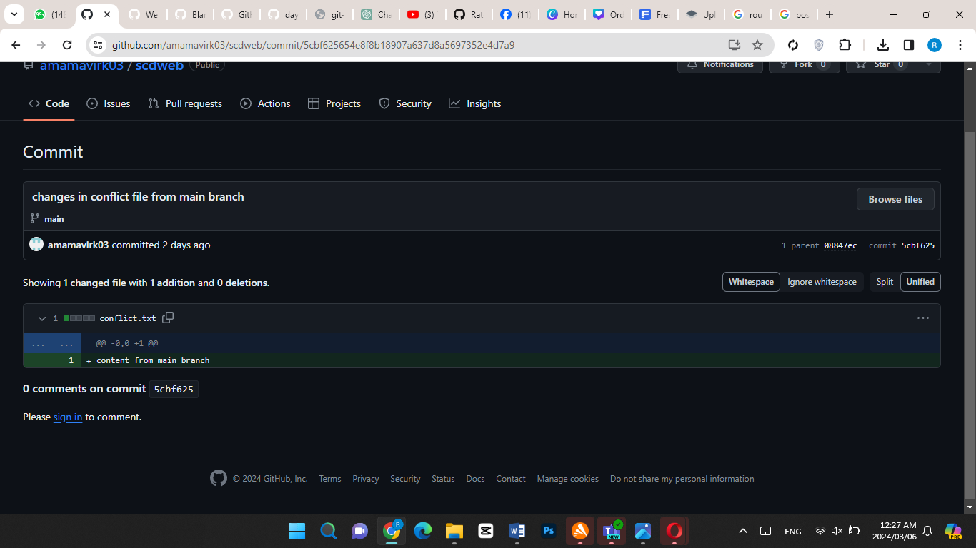

**Here the conflict arised with conflict.txt file.**

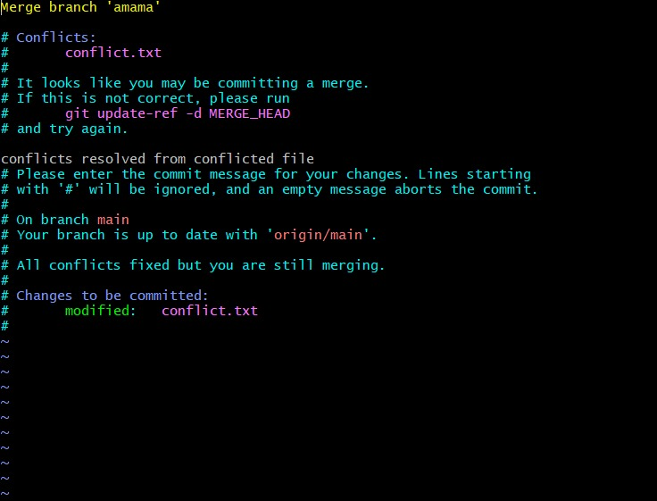

We resolved conflicts by removing markers in the editor and merging the changes collaboratively. This streamlined the code, ensuring a unified and coherent version that incorporated all relevant contributions from team members.

.gitignore file

We have added vs.code and a png file to .gitignore folder because we don’t want it to be tracked.



Git stashing

We created a branch named "documentation branch" and employed the git stash command to temporarily set aside ongoing work on the branch for future resumption. This approach allows us to seamlessly switch between tasks without losing any modifications or disrupting the version control process.

